Analysis of the plasma radiation spectra with the lines
of significantlyvarying intensity
D K Kostrin¹, A A Lisenkov², A A Uhov¹and A N Ramazanov¹
¹ Department of electronic instruments and devices,Saint Petersburg Electrotechnical University “LETI”, 197376, Saint Petersburg,Russia
² Institute of Problems of Mechanical Engineering, Russian Academy of Sciences, 199178, Saint Petersburg, Russia

E-mail: dkkostrin@mail.ru

Abstract. Range of charge accumulation times for the charge-coupled device photodetector, in which there is linearity of its signal characteristics, is demonstrated. The influence of the blooming effect during the saturation of a signal on the form of spectral lines is shown. Method of simultaneous analysis of lines of significantly different intensity using multiple summations of the emission spectra, obtained with a small time of charge accumulation, is proposed.
1. Introduction
Modern optical spectrometers are constructed on the basis of charge-coupled device (CCD) photodetectors [1]. The choice of the CCD for the construction of the spectrometer optical part is not only due to its high sensitivity, this detector has a number of other advantages. Charge emerging in the element of the CCD storage sections is proportional to the registered radiation intensity and the time interval during which the flow of charge into the potential well is blocked by the shutter.
The effect of interchangeability of radiation intensity and charge accumulation time creates possibility to control the sensitivity of the spectral device using software. Such method allows detecting the signal from sources with intensities of radiation, which differ in dozens and even hundreds of times.
The necessary duration of charge accumulation in the CCD structure is correlated with the intensity of radiation in the considered spectral range. The lower the level, the longer must be the period of charge accumulation for obtaining acceptable signal amplitude at the output of the photodetector. However, it should be noted that the generation of minority carriers in a semiconductor can occur not only due to the photoelectric effect, but also as a result of thermal ionization. Thus, for each semiconductor structure at a certain temperature there is a limit to the duration of charge accumulation and accordingly the minimum (threshold) energy of radiation that can be registered on the background of generation of thermal electrons and noise of different nature.
The number n of the thermal electrons generated in the CCD cell for time t can be written as:
(1)
where S – is the cell area; T – CCD crystal temperature; q – electron charge; ∆E – band gap of the semiconductor; k – Boltzmann constant.
The dark current is a result of spontaneous generation of electron-hole pairs. One of the most effective ways to reduce dark current and thermal noise is cooling of the CCD crystal, which in turn allows lowering the threshold energy of the registered radiation. In devices that do not require very low values of dark current Peltier elements are typically used for thermoelectric cooling.
2.Research of a light-signal characteristic of the CCD used in spectrometric equipment
Let us consider a light-signal characteristic of the TCD1304 CCD used as a receiver in many modern compact spectrometers, in particular in developed at the Department of electronic instruments and devices of Saint-Petersburg Electrotechnical University "LETI" spectrometric complex ISM3600 [2]. Time of charge accumulation in the considered spectrometer can be set in the range of 0.02...5000 ms. The lower limit is determined by the required minimum time of charge accumulation, and upper limit is due to the increase of dark current to the level of the maximum signal.
Figure 1 shows a light-signal characteristic of the CCD, obtained by measuring the spectrum of radiation of fixed intensity source – halogen incandescent lamp, connected into the current stabilizing circuit. In this case, the dark current of the CCD is subtracted from the total signal by software.
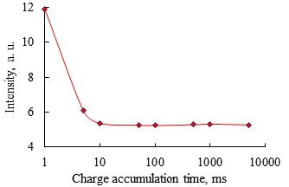
Figure 1.Light-signal characteristic of the TCD1304photodetector.
The graph (figure 1) shows linearity of the characteristic in a wide range of charge accumulation time – from 10 ms up to 5 s. There is a combination of measuring ranges – reduction of the input signal can be compensated by a proportional increase in the charge accumulation time. However, in the region of small charge accumulation times the linearity is distorted, which may be due to the properties of the CCD and the impact of the device digital circuitry. Thus, it is possible to recommend carrying out measurements of the emission spectra with the charge accumulation time of at least 10 ms. Also increasing the charge accumulation time leads to a decrease in the influence of pulsations of the radiation source, which improves the overall quality of the obtained spectra.
Optical radiation even with a very weak intensity produces electrons in the cells of the storage sections of the CCD photodetector. However the capacity of each pixel of the CCD is not limitless. If the number of photons is sufficiently large, then the quantity of generated charges may be greater than the capacitance of the pixel. In this case the signal reaches saturation and the excess charge starts to flow into adjacent cells – blooming effect occurs. The influence of blooming effect on the output signal of the CCD is reflected in the broadening of the intense lines (figure 2).It is obvious that up to a certain point the increase of the charge accumulation time leads to a linear increase in the intensity of the signal, further the effect of blooming occurs – a significant distortion of the waveform in the region of larger wavelengths can be seen [3].
It can be assumed that this distortion occurs when transferring the charge packet – capacity of cells of the transfer section is less than capacity of CCD pixels. In this case charge that will not fit into the cells of the transfer section when the transportation begins flows into the nearest cells in the direction of motion of the charge packet.
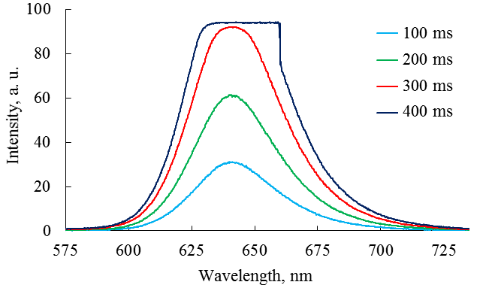
Figure 2.Blooming effect on the example of a continuous spectrum.
It can be concluded that it is necessary to carefully select the charge accumulation time in the CCD in order to avoid the effect of blooming, which could be programmatically processed in the case of uniform broadening, unfortunately not seen in the application of the TCD1304 photodetector because of its technological features.
3. Analysis of the linear spectra with the lines of significantly varying intensity
Let us consider the effect of blooming on the example of a spectrum fragment of a mercury low pressure lamp (figure 3). It can be seen that there is a significant broadening of spectral lines, which leads to considerable difficulties in determining the wavelength of the respective line. It should be noted that in the case of a linear spectrum is also observed the broadening of spectral lines towards the larger wavelengths, i. e. in the direction of charge packet transfer.
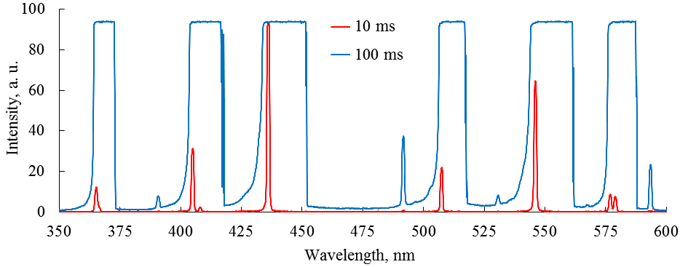
Figure 3.Emission spectra of a mercury lamp at the charge accumulation times of 10 and 100 ms.
Using this spectrum to analyze the composition of a gas mixture [4] is not practically possible because of the significant changes in the shape of spectral lines. In particular the blooming effect leads to unification of the lines of doublets (e. g. doublet 577–579 nm) and triplets into one wide line.
On the other hand, a significant increase in the charge accumulation time resulted in appearance of new spectral lines. The intensity of the individual spectral lines are often extremely small and one reading of the contents of storage sections does not allow to distinguish this weak signal on the background noise of the CCD.
Using multiple summation of a signal with subsequent averaging it is possible to make such lines suitable for analysis. Figure 4 shows a fragment of the emission spectrum of a mercury lamp obtained at the charge accumulation time 10 ms and the sum of ten consistently received such spectra. On last spectrum lines with wavelengths 489 and 491.6 nm earlier merged into one became separate.
Figure 4.Emission spectrum at the charge accumulation time 10 ms and the sum of 10 such spectra.
It is obvious that the summation of the spectra obtained using a small charge accumulation time on one hand makes it possible to consider spectral lines of low intensity and on another – to get rid of the blooming effect and not to lose information about lines of high intensity.
4. Automatic search of the spectral lines position in the analysis of spectrums
Analysis of the plasma emission spectra may involve the use of algorithms for automatic determination of the position of spectral lines, which allows qualitative and quantitative analysis of the plasma composition [5]. The main requirement is that the search algorithm is high speed, allowing the search of lines in realtime.
The task of identifying spectral lines in the linear spectra is necessary for the correct operation of the algorithms of qualitative spectral analysis. There are a number of algorithms used in chemical studies to identify series of peaks and matching them with the profiles of various materials [6]. Most of these algorithms are specialized on the analysis of the peptide components and are not suitable for the research of optical spectra. Methods of detecting peaks in the optical range are not so common. The algorithm to identify the spectral lines must provide cutoff of the noise component, accounting for the asymmetry of a signal and the solution of the problem of the nested peaks, doublets and triplets.
There are a number of approaches to the identification of spectral lines. It is worth noting the following algorithms: finding a local maximum, the method of fitting functions and wavelet analysis. Some of these algorithms do a good job of highlighting the peaks, but they run not fast enough, even using modern computing power, and lose their relevance in the analysis of spectra in real time.Let us consider the most simple and thus fast algorithms to determine the position of the spectral lines.
The first algorithm searches for the position of spectral lines by calculating the so-called center of gravity of the shape. The order of steps in this algorithm is as follows: search of the peaks in the whole spectral range, removing from consideration peaks that have low intensity, search for lower boundaries of the peaks, calculation of the center of gravity for each of the peaks.
This algorithm has sufficient performance and allows to effectively determine the actual position of spectral lines. A significant drawback of the algorithm is the inability to define the position of the lines of an incompletely resolved doublet.
The solution of this problem requires fitting into the shape of a bounding peak two mathematical Gauss, Lorentz or Voigt functions and find their parameters to obtain the existing form of peak. The wavelengths corresponding to the spectral peaks in this case are determined by the parameters of these functions. This addition to the algorithm largely reduces its performance and is not applicable for analysis in realtime.
The second considered algorithm is easier to implement and has higher performance. The procedure for it is as follows: search of the peaks in the whole spectral range, removing from consideration peaks that have low intensity, search for the left and right border of the shape of the peak on half of its height, calculation of the center of the figure.
This algorithm unlike the previous one allows handling partially resolved doublet lines. In the case of having them in spectrum the algorithm moves from a half height of the peak to the intensity of the point corresponding to the separation of adjoined lines.
The results of determining the position of spectral lines for the low pressure mercury lamp with the use of the both considered algorithms are given in table 1. Also shown for comparison are the true values of the wavelengths, as well as the positions of the maxima for the lines in the spectrum.
Table 1.The results of determining the position of spectral lines.
Algorithm | Wavelength of the spectral line, nm
Maximum of the spectral peak | 313.60 | 365.35 | 404.00 | 435.10 | 545.00 | 576.15 | 577.90
Center of the gravity of the shape | 313.45 | 365.45 | 404.55 | 435.35 | 545.30 | 577.25 | 577.25
Center of the peak on half height | 313.30 | 365.45 | 404.65 | 435.45 | 545.35 | 576.85 | 577.90
Theoretical wavelength value | 312.60 | 365.00 | 404.67 | 435.83 | 546.07 | 576.96 | 579.07
Analysis of the data given in table 1 makes it possible to conclude that both algorithms allow obtaining the values of the position of spectral lines sufficiently close to the theoretical values. The accuracy of the second algorithm (despite the fact that it is easier and faster) is higher.
5. Conclusions
Based on the conducted experiments it can be recommended when using spectral equipment built with the use of the TCD1304 photodetector to obtain emission spectra for further analysis when the output signal of the device lies in the range 20...90 a. u. (for the units of the output signal the percentage level from the maximum signal of the CCD which corresponds to its saturation is taken).
The choice of this range is due to the fact that at low values of the signal level significantly decreases the accuracy of analog-to-digital converter included in the conversion circuitry of the device, besides the signal becomes comparable with the noise level, which leads to considerable inaccuracies of the measurement. When the values of the output signal are over 90 a. u. the blooming effect begins to affect the results, leading to a dramatic broadening of the spectral lines, which creates significant difficulties in defining their position.
It can be noted that the algorithms of the search of the peak positions with their simplicity and speed enable to effectively determine the wavelengths of the spectral lines. The obtained data can further be used to evaluate the plasma composition in real time, which allows in the control of technological processes in a timely manner to respond to the changes in the plasma flux composition.
References
[1] Uhov A A, Gerasimov V A, Kostrin D K, Selivanov L M 2014 Journal of Physics: Conference Series567 012039
[2] Kostrin D K, Oukhov A A 2013 Biotechnosphere321–25
[3] Kostrin D K, Uhov A A 2013 Testing. Diagnostics5 40–42
[4] Kostrin D K, Uhov A A, LisenkovA A 2016Vakuum in Forschung und Praxis3 2–5
[5] Kostrin D K 2015 Testing. Diagnostics5 47–50
[6] Vu T N, Laukens K 2013 Metabolites3259–276

