Characteristics of a glow discharge maintainedin the vapors
of a liquid
A N Ramazanov¹, D K Kostrin¹, V D Goncharov² and A A Lisenkov³
¹ Department of electronic instruments and devices,Saint Petersburg Electrotechnical University “LETI”, 197376, Saint Petersburg,Russia
² Department of theoretical fundamentals of electrical engineering,Saint Petersburg Electrotechnical University “LETI”, 197376, Saint Petersburg,Russia
³Institute of Problems of Mechanical Engineering, Russian Academy of Sciences, 199178, Saint Petersburg, Russia

E-mail: dkkostrin@mail.ru

Abstract. Glow discharge in atmospheric pressure air in the discharge cell with a liquid cathode is considered. Current-voltage characteristic of such a system at different distances between the electrodes and various electrode placements, different thickness of the liquid layer and the cathode surface area are shown. Spectral emission of the glow discharge plasma in the vapors of a liquid is demonstrated.
In this work a system composed of the anode and submerged under the liquid layer cathode was investigated (figure 1). For ignition of the discharge was developed a high voltage scheme, which allows to vary the pulse repetition rate from 15 to 50 kHz, at a voltage from 0 to 3,5 kV (figure 2). Rod of tungsten with a diameter of 4 mm, sharpened at an angle of 30°, separated from the liquid by an air gap in which discharge occurs upon application of high voltage, is used as the anode.
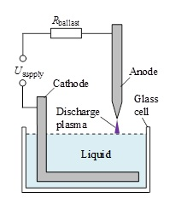 |  | 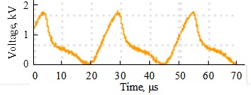  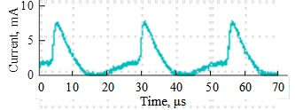
Figure 1. Simplified design scheme of the discharge cell. |  | Figure 2. Voltage and current oscillograms of the glow discharge.
While using a similar supply system conductive liquid plays the role of distributed resistive-capacitive ballast. Distance from the anode to the surface of the liquid was varied in the range 3...10 mm. In the case where it is not specified the thickness of the liquid layer above the metal cathode in the experiments was equal to 4 cm.
Current-voltage characteristics (I–V curves) of the studied system (the glow discharge and the distributed liquid ballast) at different distances d between the anode and the surface of the liquid are shown in figure 3. The results were obtained at a constant frequency of 40 kHz. Similar results were observed in the whole investigated frequency range.
At d = 4...6 mm the discharge was burning only in the certain ranges of frequencies and voltages. At d = 5 mm frequency range of the discharge was 19,5...50 kHz. At d = 3 mm the discharge was maintained over the entire range of frequencies and voltages. The high brightness of the glow discharge is observed at currents exceeding 20 mA.
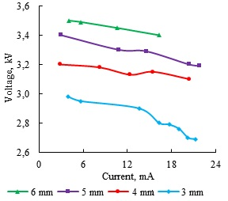 |  | 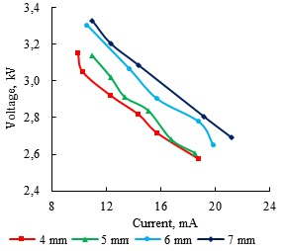
Figure 3. I–V curves of the glow discharge at different distances metal anode–liquid cathode. |  | Figure 4. I–V curves of the glow discharge at different thickness of the liquid layer above the metal cathode.
As the distance between the liquid surface and the cathode is changed I–V curves of the discharge become more steeply dipping (figure 4). As a result the energy contributed into the discharge decreasesand, consequently, the brightness of its radiance reduces. In this experiment the distance between the metal anode and the liquid was maintained equal to 3 mm.
The increase in the current flowing in the discharge gap leads to a change in the shape of the discharge – from cone, in which there is a uniform current distribution on the surface of the liquid, to ellipse, in which there is a "binding" of the discharge to a specific area on the surface of the liquid. In this case the distributed resistance of the liquid layer is not enough to limit the current and instabilities, inherent to the glow discharge, lead to its contraction and the formation on the surface of the liquid of an explicit cathode spot [1]. This spot move quickly across the surface of the liquid.
In the next experiment the influence of the surface area of the metal cathode located in the depth of the liquid on the I–V curves of the gas discharge was investigated (figure 5). Originally the area of a rectangular plate was equal to about 14 mm2. With the decrease in the surface area of the metal cathode decreases the voltage of the discharge sustaining, this fact is connected with the decrease of the resistance of the liquid volume through which an electric current flows.
Similar results can be obtained while shifting the anode relative to the cathode. The results of this experiment are shown in figure 6. With the shift of the anode increases the distance between the electrodes, which leads to an increase of the discharge voltage, and also increases the distributed resistance of the liquid, which leads to a sharper voltage drop with the increasing current.
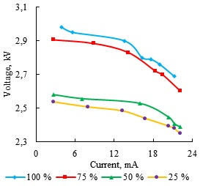 |  | 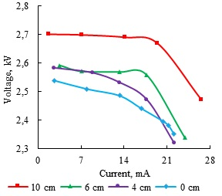
Figure 5. I–V curves of the glow discharge at different surface areas of the metal cathode. |  | Figure 6. I–V curves of the glow discharge at different positions of the anode relative to the metal cathode.
Spectrogram of the atmospheric pressure discharge in the air between the metal anode and the liquid surface was received using a spectrometer ISM3600 [2, 3]. Processing of the obtained spectra was performed using the Aspect2010 software [4]. One of the main functions of this software is plasma emission spectrum analysis.As the test liquid in all the experiments tap water was used.
In figure 7 a spectrogram of the glow discharge with liquid cathode at a distance between the anode and the water surface d = 4 mm and the frequency of the supply voltage of 30 kHz is shown. The sensitivity of the spectrometer (charge accumulation time) is equal to 2 s.
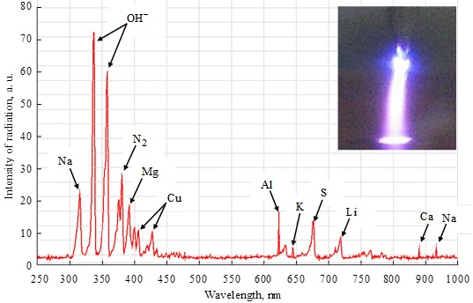
Figure 7.Spectrogram of the glow discharge with liquid cathode (the inset shows a photograph
of the discharge).
The most intense emission spectral lines of the glow discharge plasma are concentrated in the interval of wavelengths 300...400 nm and correspond mainly to the hydroxyl group OH–,singly charged ions of nitrogen N+ and oxygen O+ and also molecular nitrogen and oxygen. In the visible wavelength range spectral lines of molecules of lithium, copper, potassium, sulphur and aluminum are observed. In the range 800...1000 nm peaks corresponding to calcium and sodium can be seen.
The efficiency of the spectral lines excitation for various elements is different and strongly depends on the electric parameters of the discharge and the structural characteristics of the discharge cell and even the temperature of the liquid. During the experiment it was found that the use of more hot water shifts the I–V curves of the discharge in the direction of lower voltages.
References
[1] Bystrov Yu A, Kostrin D K, Lisenkov A A, Vetrov N Z 2015Vakuum in Forschung und Praxis222–25
[2] Kostrin D K, Oukhov A A 2013 Biotechnosphere321–25
[3] Kostrin D K, Uhov A A, LisenkovA A 2016 Vakuum in Forschung und Praxis3 2–5
[4] Uhov A A, Gerasimov V A, Kostrin D K, Selivanov L M 2014 Journal of Physics: Conference Series567 012039
[5]
[6]
[7]

